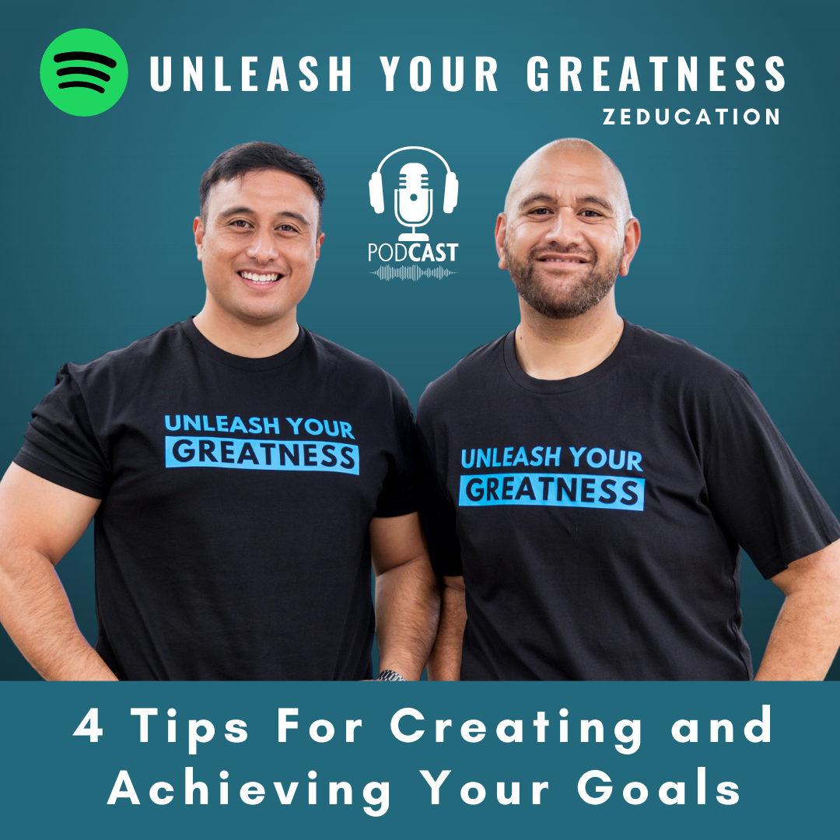

We recommend that you listen to the full podcast on Spotify to help understand how to use this template effectively.

Link to full podcast: https://open.spotify.com/episode/1p9HFpD1Eok5XKH8u15Npe?si=b554fc5dc4724734

What are your most important goals? | Purpose and Motivation | Deadline | Be Self-Aware | Make it Practical & Achievable
Goal:  [example]  Become a better leader in in my workplace and home | Why is this goal important to me?  [example]  I want to be someone that people look up to and feel inspired to do and be better as a result. I want my kids to know how much of a great leader I am. | When do you want to achieve this goal and why?  [example]  By the end of December 2023. Good time to reflect on Christmas and see how far we have come together compared to previous years. | What 3 patterns of action will prevent me from achieving my goal?  [example]  1 - Complaining and speaking ill of others  2 - Becoming emotionally aggressive and reactive  3 - Not listening and talking over people | What 3 patterns of action will help me achieve my goal?  [example]  1 - Bringing positivity into every room and conversation by being positive.  2 - Investing in personal & professional development daily by reading books.  3 - Listening to people attentively and helping them to solve their problems.  4 - Serving my team. Even just the little things.  5 - Inspiring my team by sharing and living the principles that I learn
Goal: | Why is this goal important to me? | When do you want to achieve this goal and why? | What 3 habits will prevent me from achieving my goal? | What 3 habits will help me achieve my goal?
Goal: | Why is this goal important to me? | When do you want to achieve this goal and why? | What 3 habits will prevent me from achieving my goal? | What 3 habits will help me achieve my goal?
Goal: | Why is this goal important to me? | When do you want to achieve this goal and why? | What 3 habits will prevent me from achieving my goal? | What 3 habits will help me achieve my goal?
Goal: | Why is this goal important to me? | When do you want to achieve this goal and why? | What 3 habits will prevent me from achieving my goal? | What 3 habits will help me achieve my goal?
Goal: | Why is this goal important to me? | When do you want to achieve this goal and why? | What 3 habits will prevent me from achieving my goal? | What 3 habits will help me achieve my goal?
Goal: | Why is this goal important to me? | When do you want to achieve this goal and why? | What 3 habits will prevent me from achieving my goal? | What 3 habits will prevent me from achieving my goal?

